Ethnomathematics : Eksploration of Traditional Crafts Tapis Lampung as Ilustration of Science, Technology, Engineering, and Mathematics (STEM)

Suherman¹ *
¹ Mathematics Education, UIN Raden Intan Lampung, Lampung, 35131, Indonesia
* E-mail: suherman@radenintan.ac.id

Abstract
This study aims to exploration of traditional crafts Tapis Lampung as ilustration STEM. This research is a qualitative research with an ethnographic approach. The results showed that (1) Science: as an illustration of the ability of scientific knowledge and biological acculturation processes found in animal motive that describe the elements of science, such as the Tapis Tuho motive which has dragon animal motives, aro wood, stars silver, and sasab titled. (2) Technology: as an illustration of new technologies emerging from globalization with the entry of Islam in Lampung, the implications for communication and traffic between the Indonesian archipelago so that the use of shipping transportation is needed, can be explored from the existence of a Tapis Single Ship which shows the diversity of forms and construction. (3) Technology: as an illustration of engineering technology that is developed through an design process by integrating other elements, it can be explored from the mountains motives, dragon ship motives, and hill motives that resemble bridges. (4) Mathematics: as a geometrical illustration of transformation, which can be expressed as a form of translation, rotation), reflection, and dilation.. Through the investigation of Tapis Lampung, it can be used as a source to disseminate and provide information about Indonesian local wisdom to the world.

Keywords: Tapis Lampung; Science, Technology, Engineering, and Mathematics (STEM)

INTRODUCTION
The Indonesian state is a country that consists of various islands, ethnic groups, languages, and cultures. Indonesian cultures produce works of art that are countless in quantity and quality (Letivany, 2015). Each region is not the same, so that it can become the Indonesian capital for cultural expansion ammunition (local education) but what happens is that Indonesia's local culture continues to be eroded by globalization without a strategy of cultural preservation.
One of the provinces in Indonesia is Lampung Province. Lampung Province is known for its natural resources and customs such as language, traditional ceremonies, customs, traditional houses, dances, songs, music, traditional clothing and various handicrafts. Traditional society of Lampung have applied these concepts in their daily lives using ethnomathematics (Rakhmawati, 2016). Lampung Province has traditional handicrafts that are characteristic and as identities, namely Tapis Lampung. It can be seen that, Tapis is a characteristic of the people of Lampung. The Lampung tribe began to recognize woven fabric weaving during the 2nd century BC, known as woven fabric and console systems (Key and Rhomboid Shep) with the motive of the tree of life and the motif of the building which contains a picture of a person who symbolizes the spirit of a deceased human (Firmansyah R.A & Suprihatin, 1996).
Tapis is a kind of traditional cloth of Lampung people shaped like a sarong made from woven cotton thread with a variety of motives, such as: geometric, human, nature, flora, and fauna which are embroidered using a cucuk system with gold thread, silk thread and or thread silver (Husna Azhari, 2011). However, the motives of various Tapis Lampung generally consist of three parts, namely: plant motives, geometric motives, and mixed motives between plants and geometric patterns. Tapis Lampung includes traditional handicrafts because the equipment used in making basic fabrics and decorative motives is still simple and done by craftsmen. This craft was made by women, both housewives and girls who initially spent their free time with the aim of fulfilling the guidance of customs that were considered sacred (Pusliati, 2006). Tapis is not only used by the nobility, but also by ordinary people in Lampung. Tapis is also a form of income and local commodities of the Lampung community. The tapis cloth becomes a local commodity that is constantly in demand, as both the indigenous people of Lampung and settlers are required to wear it (HARTONO, 2012). In addition, the physical form, ornamental variety and symbolic-philosophical meaning also also experienced development and change. If initially the Tapis is made specifically for customary needs which symbolize certain meanings, then now it has shifted only in terms of its beauty and to obtain economic benefits only. This can be seen from the increasingly diverse derivation of products tapis, both in their physical form and in their decorative motives. If at first the filter product is only a traditional cloths for noble women, now it has undergone modification and diversification so as to create a variety of art tapis, craft products, such as muslim fashion, wall hangings, calligraphy, bathroom fixtures, bags, wallets, skullcap, places tissue, and so on.
The beauty of the tapis can be enjoyed from artistic forms poured on sheets of cloth. If observed carefully, in actual tapis forms there are rhythmic or patterned regularity traits. Some forms of order on the tapis are geometric transformations. On the other hand, Euclidean geometry is used to prescribe human-made forms such as rectangles, circles, spheres, triangles, etc. (Munir, 2004).
The fact that the structure is a geometric transformation seems to be the thing that shows that there is a hidden wisdom in the depiction of the world that is unlike Aristotelian geometry. This is explicit in the works of the tapis. The fact of fractality in the future as an aspect of visual culture that is closely related to Indonesian culture and civilization is also a very important thing to learn and pay attention to. Tapis is the result of embroidery by using gold thread following repetitive motifs and patterns. This repetitive nature is closely related to geometry (Letivany, 2015).
The universal notion of mathematics is further strengthened by the fact that it was created throughout the world (Yusuf, Ibrahim Saidu, & Halliru, 2010). Mathematics as human activities, mathematics and education are combined, this mixing is often called ethnomathematics (Tandililing, 2015).
The term ethnomathematics was coined by D’Ambrosio to describe the mathematical practices of identifiable cultural groups and may be regarded as the study of mathematical ideas found in any culture (d’Ambrosio, 1985). Defined ethnomathemat ics in the following way: The prefix ethno is today accepted as a very broad term that refers to the socialcultural context and therefore includes language, jargon, and codes of behavior, myths, and symbols The derivation of mathema is difficult, but tends to mean to explain, to know, to understand, and to do activities such as ciphering, measuring, classifying, inferring, and modeling. The suffix tics is derived from techné, and has the same root as technique (Orey & Rosa, 2007).
In other words, ethno refers to members of a group within a cultural environment identified by their cultural traditions, codes, symbols, myths, and specific ways used to reason and to infer (Orey & Rosa, 2007). Mathema means to explain and understand the world in order to transcend, manage and cope with reality so that the members of cultural groups can survive and thrive, and tics refer to techniques such as counting, ordering, sorting, measuring, weighing, ciphering, classifying, inferring, and modeling. (Rosa & Orey, 2003) states that the mathema evelops the tics within the context of ethnos because it consists of daily problems people face, larger problems of humanity, and endeavours of the humans to create a meaningful world (Orey & Rosa, 2007).
Mathematics is identified in cultural activities in traditional and non-traditional societies (Orey & Rosa, 2007). This means that ethnomathematics refers to mathematical concepts embedded in cultural practices and recognizes that all cultures and all people develop unique methods and sophisticated explications to understand and to transform their own realities (Rosa & Orey, 2011).
STEM is an acronym for science, technology, engineering, and mathematics (Chen, 2009), which is an important issue in education trend today (Becker & Park, 2011) and recognized international skills needed to advance society in the 21st century as well as the foundation of economic growth (Council & Council, 2014; English, King, & Smeed, 2017). The STEM approach is a learning approach that integrates two or more disciplines contained in the STEM or among the disciplines contained in the STEM with one or more other subjects (Sanders, 2008). The STEM approach is a learning approach that combines two or more fields of science contained in STEM namely science, technology, engineering / engineering, and mathematics (Ismayani, 2016; Utami, Jatmiko, & Suherman, 2018).

METHODS
This research is a qualitative research. Whereas the approach taken in this study is an ethnographic approach that is an empirical and theoretical approach that aims to get an in-depth description and analysis of culture based on intensive fieldwork research. This approach focuses on efforts to discover how to explore culture combined with elements of STEM. The task of ethnography is to find and describe the organization of thought.

RESULTS AND DISCUSSION
- Science
Science discipline, focus on the ability to use scientific knowledge and processes to understand the natural world and the ability to participate in making decisions to influence it. Other, science is a way of knowing and verifying not just an organization of collected facts. Science has to do with biology, physics, marine biology, and chemistry. In Tapis Lampung, there are animal motives that describe the elements of science, as in the following picture:

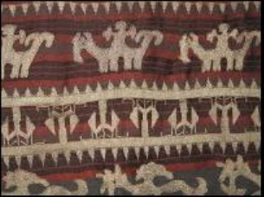  Picture 1. Tapis Tuho Motives | 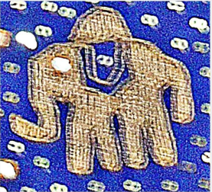  Picture 2. Elephant Animal Motives

Tapis Tuho motives have of dragon animal ornaments, aro wood, silver stars, and sasab titled. This tapis tuho cloth is usually used by a wife who is taking a sutan degree. It can also be used by parents (mepahao) who are taking the sutan title as well, and can also be used by sutan wives who are attending a ceremony to take the title of a close relative. The following are elements of the plant form, namely aro wood. Aro wood is a form element found in the Tapis Tuho motive which has the meaning of fertility and has confidence in the previous community. Aro wood is in the form of a rod with branches branching in all directions. This motif symbolizes the element of life that is as a source of human life, which generates human life and can also be called a symbol of justice and prosperity of the people of Lampung.
The motives applied to the elephant tapis are non-geometric and geometric. The elements of the form include Elephant motives, human, human motives for riding a boat, and chain-link motives. The composition applied to this product is taken by plants and combined with animal motives, handler motifs, human motives on board a boat, and chains to make it look attractive. The main motive is the elephant animal which is depicted standing upright between the motives of the handler and human motives.

- Technology
Technology discipline, can be interpreted about the knowledge of how to use new technology, understand how new technology is developed, and have the ability to analyze how new technologies affect individuals, society, nation, and country. The people of Lampung have weaved Brocade fabrics called trays and cloths from the second century AD. The motives is hooks or Key and Rhomboid Shape, Hayat Trees and buildings that contain dead human spirits. The entry of Islam in Lampung, it also enriched the development of this woven cloth woven craft. Although the new element has an effect, the old element is retained. The existence of communication and traffic between the Indonesian islands is very possible for the population to develop a maritime network. The maritime world or the maritime era has begun to develop since the days of the Indonesian Hindu kingdom and reached its glory during the growth and development of Islamic kingdoms between 1500-1700. Starting from this historical background, the imagination and creation of the creator of the artist clearly influences the results of the work taken by ideas in everyday life that take place around the artist's environment where he lives. The use of shipping transportation at that time and the natural environment of the sea has given the idea of ​​using decorative motifs on the fabric motives of the ship. Variety in ship fabric motives on ship fabric shows the diversity of shapes and construction of ships used.

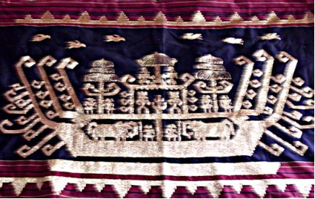

Picture 3. Single Ship motives

- Engineering
Engineering discipline, understanding of how technology can be developed through an design process using project-based learning themes by integrating from several different subjects (interdisciplinary). In relation to Tapis Lampung, there are elements of the motives that are combined, both from ships, plants, animals, and geometry. Seen from the formation of the dragon ship motives.
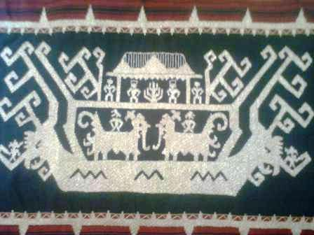

Picture 4. Dragon Ship Motives

- Mathematics
Tapis Lampung has a geometric shape, in the form of points, lines and flat fields. These flat fields are for example circles, ellipses, rectangles, and triangles. The artistic form of the filter is generated through the transformation of the point, line or flat plane through translation, rotation, reflection or dilation. On the other hand, the transformation is a change in appearance, shape, nature and function.
- Translation on Tapis Lampung
According to Gatut Iswahyudi, translation can be defined as a mapping $S$ called translational if there is a line segment directed $AB$ so that for each point $P$ in the field $V$ applies $S\left(P\right)=Q$ with $PQ=AB$ (Iswahyudi, 2003)
Based on the above definition, translation can be stated in the coordinate plane. Suppose that given points $A(a,b)$ and $B(c,d)$. Translation $S_{AB}$ expressed analytically as $S_{AB}\left(\left(x,y\right)\right)=\left(x+\left(c-a\right)\right), y+(b-d))$ can be described as follows:

The graph shows that, if $P(x,y)$ and $S_{AB}\left(P\right)=P^{'},$ so $P^{'}=\left(x+\left(c-a\right), y+\left(d-b\right)\right).$ Then the translation for $S_{AB}$ mapping for $P(x,y)$ to $P^{'}(x^{'}, y^{'})$ can be formulated as $x^{'}=x+(c-a)$ and $y^{'}=y+(d-b)$ or by writing vectors $\left[\begin{matrix}x^{'} \\ y^{'}\end{matrix}\right]=\left[\begin{matrix}x \\ y\end{matrix}\right]+\left[\begin{matrix}c-a \\ d-b\end{matrix}\right]$. Vektors $\left[\begin{matrix}c-a \\ d-b\end{matrix}\right]$ is traslation vektors.
As an illustration, the slope mtoves are one form that illustrates the translation of geometric transformations. The slope motives are the most popular type of motive in Lampung society. This motive is also often used as a craft / art teacher as a duty of students in school (Lampung) in making a fabric tapestry that is patterned on slopes. The motions of the slopes are also often used by filter fabric producers as the main motive. The color on the back of this motive is red, black, and yellow and the color of the tapis resembles the shape of golden slopes to make it look more harmonious and beautiful. We can observe that the motions of the slopes are simple motives in filtering the filter. The basic forms of the slope motive are as follows:
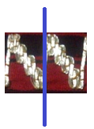

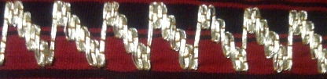 | 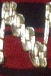
Picture 5: Slops Motives

Furthermore, the merging of the basic shapes in the figure above to the vertical line produces a shape in picture 5. The motive of the slopes above is a form of repetition / shift from the basic motive form. The repetition of the motive will shift along the desired range of filter fabric. If for shawl fabric, usually along the range $2m$ until $3m$.
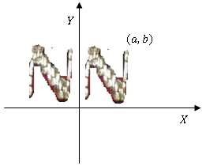
Suppose the motive of the slopes is placed on the cartesian axis, then the form of the next motif is obtained through translation vektors $T_{1}=\left(\begin{matrix}0 \\ -b\end{matrix}\right)$ follows:

Picture 6: Slop Motif on the Cartesian Coordinate
The picture above shows the basic shape of the motions of the slopes illustrated as a form of translation. If the shape is shifted, then geometrically transform can use vector formulas $T_{n}=\left(\begin{matrix}0 \\ -nb\end{matrix}\right)$ with $n$ is an original number so that the series of motives that form the slopes are as shown (picture 6).

- Rotation on Tapis Lampung
Rotation is the displacement of points, lines, or fields so far $θ$ from a certain point. Rotation can be defined: Let $A$ be any point and $α$ any number of radiaans. The papping n whics $A$ goes into self, and any other point $P$ of the plane goes into the point $P^{'}$ such that $AP=AP^{'}$ and ${∠PAP}^{'}=α$, is called a rotation or, more exactly, a rotation about $A$ through the angle $α$. $A$ is called the center of the rotation (Gans, 1969).
Suppose the point$P(x,y)$ is that any point in the plane $V$ is rotated by $θ$ (0,0), then the shadow $P^{'}(x^{'}, y^{'})$ will be obtained. The description of the above definition can be illustrated with the following picture:

Picture 7. Rotation Ilustration

Based on the picture, the rotation formula will be obtained as follows:
$R\left(O,θ\right); P\left(x,y\right)→P^{'}\left(x^{'}, y^{'}\right)$ ⁼
$$P^{'}(x\cos{θ}-y\sin{θ},x\cos{θ}+y\sin{θ}$$
The formula can be expressed by the matrix equation as follows:
$$\left(\begin{matrix}x^{'} \\ y^{'}\end{matrix}\right)=\left(\begin{matrix}\cos{θ} & -sin{θ} \\ \sin{θ} & \cos{θ}\end{matrix}\right)\left(\begin{matrix}x \\ y\end{matrix}\right)$$
As a rotation illustration, the following is one of the motives of a box

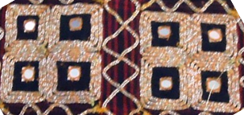

Picture 8. Ilustration Box Motif

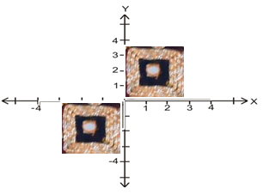
If the image is rotated against an angle ${90}^{0}, {180}^{0}, {270}^{0},$ and ${360}^{0}$ than will produce the original image. The following is the rotation form of the basic shape in the picture above

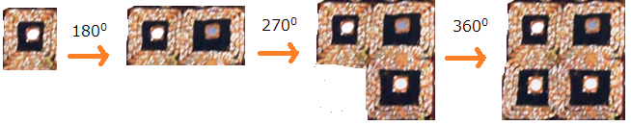  Picture 9. Rotation on Box Motives | Picture 10. Rotation on Cartesian Coordinate

The picture of the motive shows an illustration of the rotation result of the basic shape motive. If the image is rotated counter-clockwise, it will produce an illustration of the transformation of geometry with the same image.
In an analysis that if the point $P(x,y)$ is any point on the plane $V$ that is rotated at $θ$ by point $A(a,b)$,, then the shadow $P^{'}(x^{'}, y^{'})$, will be obtained, with
$$x^{'}-a=\left(x-a\right)\cos{θ}-\left(y-b\right)\sin{θ}$$
$$y^{'}-b=\left(x-a\right)\sin{θ}+\left(y-b\right)\cos{θ}$$
The equation can be expressed with the following matrix:
$$\left(\begin{matrix}x^{'} \\ y^{'}\end{matrix}\right)=\left(\begin{matrix}\cos{θ} & -sin{θ} \\ \sin{θ} & \cos{θ}\end{matrix}\right)\left(\begin{matrix}x-a \\ y-b\end{matrix}\right)+\left(\begin{matrix}a \\ b\end{matrix}\right)$$

- Reflection on Tapis Lampung

Reflection is a type of geometrical transformation that uses the shadow properties of a mirror in its displacement. If $g$ is any line, the mapping in which each point of $g$ goes into self, and every point of the plane goes into the symmetrical point with respect to $g$ is called a reflection, or more exactly, a reflection in $g,$and $g$ is called the axis of the reflection (Gans, 1969).
These definitions can be expressed as the following figure:

Picture 11. Reflection on Line $g$
Based on the picture above, it can be shown that points $P, Q, R$ are non-cholinear, and the points $P^{'}, Q^{'}, R^{'}$ are reflected on the line $g$. $\overline{{PP}^{'}},\overline{{QQ}^{'}, } \overline{{RR}^{'}}$ which divides the two corners by g. It is clear that the reflection of the image is 1-1 onto itself. And clearly seen in figure 11 above.
The following is a geometric illustration of the transformation of an elephant on a ship. The motif applied to the elephant tapis is non-geometric motive. The elements of the form include Elephant motives, human motives, human motives for riding a boat, and chain-link motives. Composition what is applied to this product is taken from the plant shape and combined with animal motives, handler motives, human motives on boarding boats, and chains to make it look attractive. The main motive is the elephant animal which is depicted standing upright between the motives of the handler and human motives.

The motive above is a vessel filter motive with elements of motives such as bamboo shoots, single ships, handlers, and elephant animals. As for the characteristics found in the woven fabric, the motif of the ship is a form of a ship containing crew, and elephants. The shape of the elephant motive on the ship can be seen as a result of reflection. The reflection form can be oriented as follows:
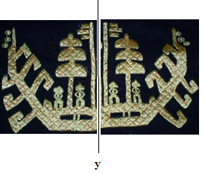

Picture 12. Ship Motive

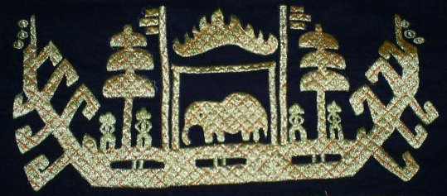  Picture 13. Ship Motive | 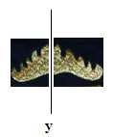  Picture 14. Reflection by y-axis$x$

In addition to the motives above, there are also filter motifs which are the result of reflection. The other elements are siger motive.

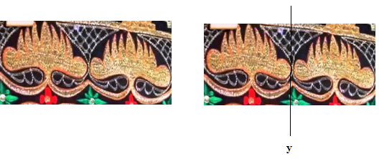

Picture 16. Siger Motive and Reflection

In the analysis, the picture above shows two Siger Lampung motives which are the result of mirroring towards the $y$-axis, the results of the reflection will produce the same image, both reflected on the $x$-axis and $y$-axis

In addition, there are also filters with Tajuk Berayun motifs, as in the following picture:
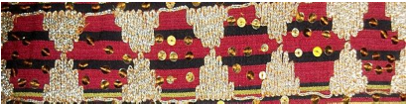

Picture 17. Tajuk Berayun Motive
Tajuk Berayun motive is usually used on Tapis Pucuk Rebung. The use of this swinging canopy ornament is located on the edge of the motif. This swinging header element is placed face to face. The application of this form element is taken from young bamboo plants. Has the meaning of fertility because of the existence of fertile natural influences. The motif of bamboo shoots is closely related to the social (value) system and the religious system or belief in the Almighty God. This motive is also a portrayal of the relationship between humans and God, fellow human beings and the environment. Pucuk Rebung motives used by groups of wives who will attend a wedding, degree taking, circumcision and so on. If viewed geometrically, the Tajuk Berayun motive is a reflection illustration.
The following is another motif which can be seen as a geometrical illustration of reflection.

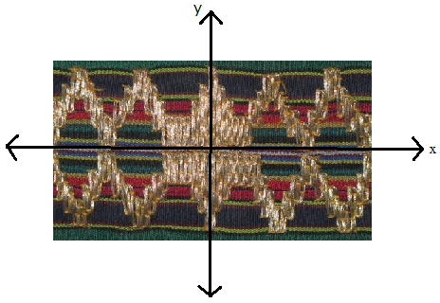

Picture 18. Tajuk Berayun Motive and Reflection
Based on the picture above, it can be seen that, the motive can be viewed as a reflection of the $x$-axis, $y$-axis, $y=x$, or $y=-x$. Or mathematically can formulate as follows
- Reflextion of the $x$-axis, then for any point $\left(x,y\right)$ mapped to $\left(x,-y\right)$, or mathematically

$M_{x}:P\left(x,y\right)→P^{'}\left(x^{'}, y^{'}\right)=P^{'}(x, -y)$.

then the transformation matrix is $\left[\begin{matrix}1 & 0 \\ 0 & -1\end{matrix}\right]$. With equations in matrix form

$$\left(\begin{matrix}x^{'} \\ y^{'}\end{matrix}\right)=\left(\begin{matrix}1 & 0 \\ 0 & -1\end{matrix}\right)\left(\begin{matrix}x \\ y\end{matrix}\right)$$
- Reflextion of the $y$-axis, then for any point $\left(x,y\right)$ mapped to $\left(x,-y\right)$, or mathematically

$M_{y}:P\left(x,y\right)→P^{'}\left(x^{'}, y^{'}\right)=P^{'}(-x,y)$. then the transformation matrix is $\left[\begin{matrix}-1 & 0 \\ 0 & 1\end{matrix}\right]$. With equations in matrix form: $\left(\begin{matrix}x^{'} \\ y^{'}\end{matrix}\right)=\left(\begin{matrix}-1 & 0 \\ 0 & 1\end{matrix}\right)\left(\begin{matrix}x \\ y\end{matrix}\right)$
- Reflextion of the $y=x$, then for any point $\left(x,y\right)$ mapped to $\left(y,x\right)$, or mathematically

$$M_{y=x}:P\left(x,y\right)→P^{'}\left(x^{'}, y^{'}\right)=P^{'}(y,x)$$

then the transformation matrix is $\left[\begin{matrix}0 & 1 \\ 1 & 0\end{matrix}\right]$.
- Reflextion of the $y=-x$, then for any point$\left(x,y\right)$ mapped to $\left(-y,-x\right)$, or mathematically

$M_{y}:P\left(x,y\right)→P^{'}\left(x^{'}, y^{'}\right)=P^{'}(-x,y)$. With equations in matrix form $\left[\begin{matrix}0 & -1 \\ -1 & 0\end{matrix}\right]$. With equations in matrix form: $\left(\begin{matrix}x^{'} \\ y^{'}\end{matrix}\right)=\left(\begin{matrix}0 & -1 \\ -1 & 0\end{matrix}\right)\left(\begin{matrix}x \\ y\end{matrix}\right)$

- Dilatation on Tapis Lampung
Dilation (multiplication) is a transformation that moves a point on the geometry that depends on the center of the dilation and the factor (scale) of the dilation. As a result, shadows from the geometry that are dilated change in size (small or big). For example, here is Jung Sarat motive with the Mato Kibaw motive

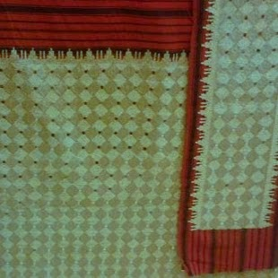  Picture 19. Tapis Jung Sarat with Mato Kibaw Motive | 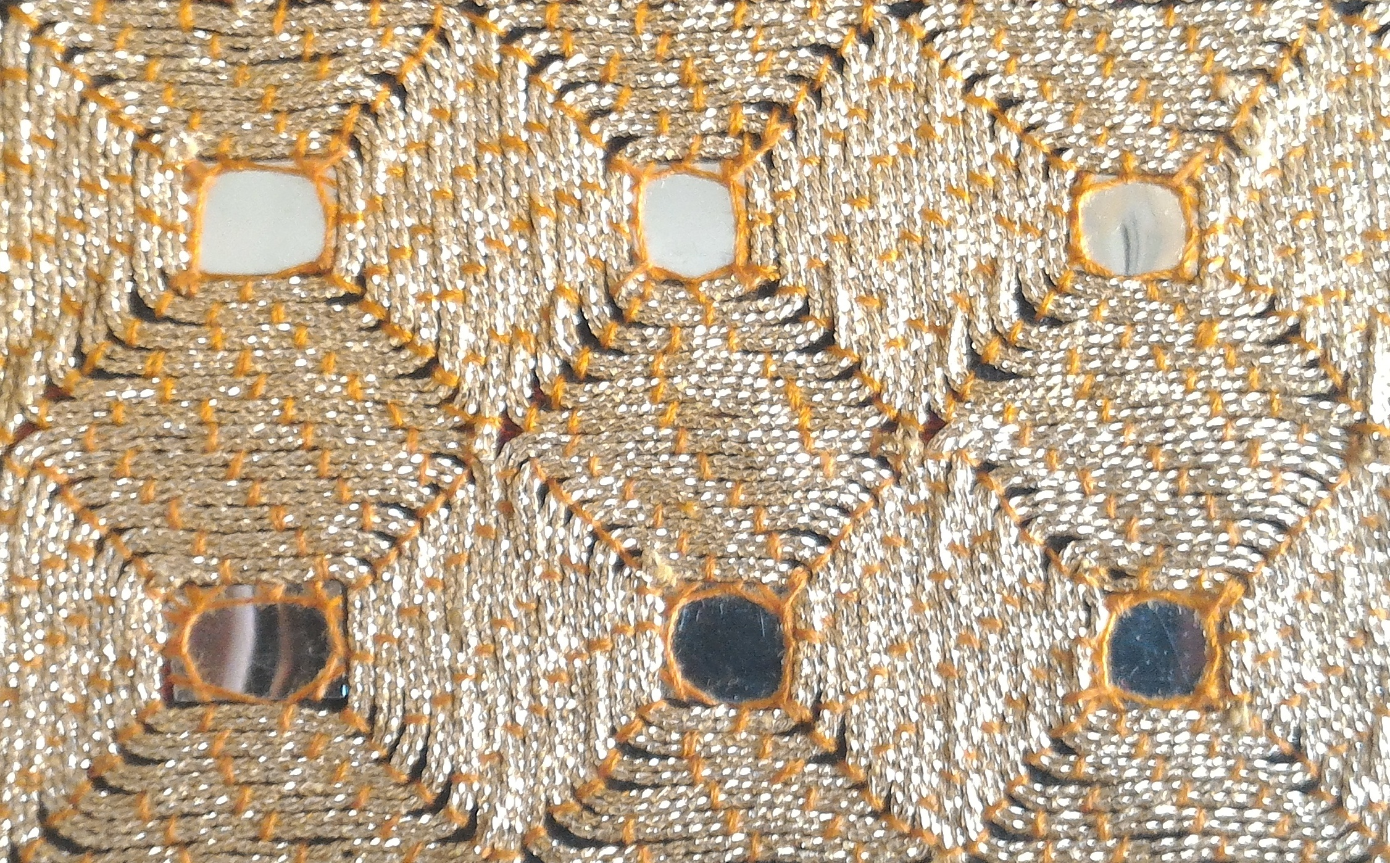  Picture 20. Partial of Mato Kibaw Motive
The motive above, can be seen as a dilation or multiplication. The motif is enlarged to get an attractive shape. Partially, the motifs are presented in the form of figure 20. The motive above can be viewed as a group of Mato Kibaw motifs partially (separately), which comes from a square building in the middle of which is a white dot made of thin zinc sheets. The motives above have different sizes, if enlarged it will produce the form as shown in Figure 9, which can be viewed as a result of dilatation or multiplication with a constant k to a partial shape, where k is a positive real number.
Mathematically, it can be seen that, suppose k is a dilated factor then the following relationship applies.
- If k > 1 then the shadow builds up and lies unilaterally against the center of dilation and wakes up.
- If 0 < k < 1 then the shadow is reduced and lies unilaterally towards the center of dilatation and the original build.
- If –1 < k < 0 then the shadow build is reduced and lies opposite to the center of dilation and wakes up.
- If k < –1 then the shadow builds up and is located opposite to the center of dilatation and wakes up.
We can understand that, the shape of the Mato Kibaw motif is a dilated form of the center point of $O(0,0)$ by mapping:
$$\left[O,k\right]:P(x,y)→P^{'}(kx,ky)$$
Equation matrix
$\left(\begin{matrix}x^{'} \\ y^{'}\end{matrix}\right)=\left(\begin{matrix}k & 0 \\ 0 & k\end{matrix}\right)\left(\begin{matrix}x \\ y\end{matrix}\right)$.
On the other hand, there is a dilation of the center point $A(a,b)$. Centre point
$P\left(x,y\right)$is dilated to the center point $A(a,b)$ with the scale k factor, obtained by the result of dilation $P^{'}\left(x^{'}, y^{'}\right)$ with $x^{'}-a=k\left(x-a\right)$ dan $y^{'}-b=k\left(y-b\right)$
with the equation matrix
$$\left(\begin{matrix}x^{'} \\ y^{'}\end{matrix}\right)=\left(\begin{matrix}k & 0 \\ 0 & k\end{matrix}\right)\left(\begin{matrix}x-a \\ y-b\end{matrix}\right)+\left(\begin{matrix}a \\ b\end{matrix}\right)$$

Based on the analysis, another motive can be displayed which is a form of expression of dilation or multiplication

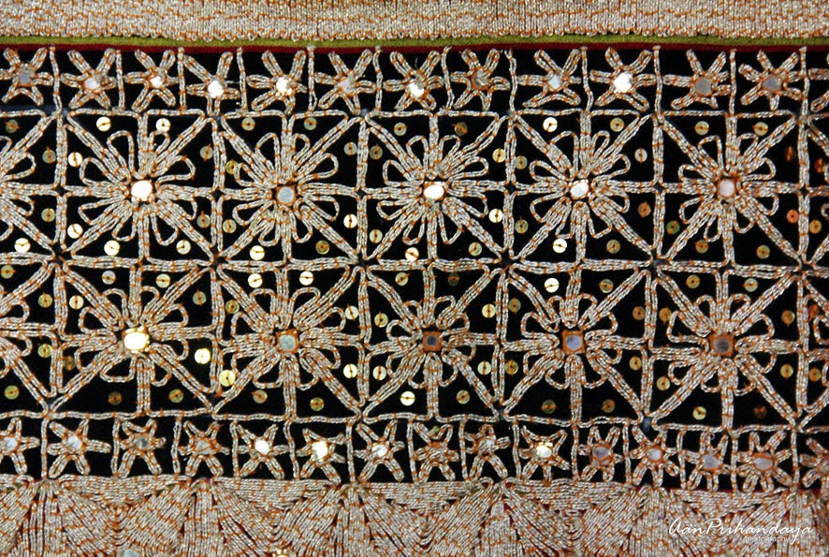  Picture 21. Flaura Motive (Mato Kibaw) | 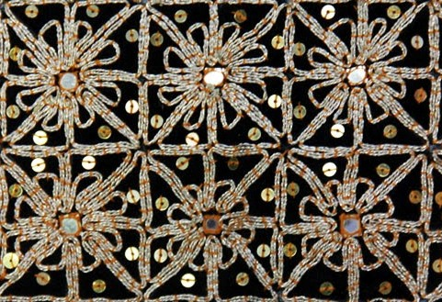  Picture 22. Partial of Flaura Motive

The motive above, can be seen from a point that is enlarged into a flower shape. Suppose that the flower motive in figure 22 is seen as a result of being dilated by the constant k against the midpoint, with k positive real numbers. And is stated as A. For example $k_{1}=2$, then the form $k_{1}A$ is twice the magnification $A$, can be expressed as $k_{1}A=A_{1}$
The above are some examples of transformation geometry applications in filter artwork. Patterns on filter motives can have sacred values, social stratification, history and understanding of nature, creativity, inclusiveness, and economic value. First, sacred value. Filter cloth is usually used in traditional ceremonies which are a symbol of the purity of the Lampung people. The sacred value can be seen from motives that contain symbolic-philosophical meanings such as buildings. Second, social stratification. Tapis as a sign of social status. Third, historical value and understanding of nature. With the tapis, it can be known the history of the development of Lampung society and the natural conditions of Lampung. For example, the use of various types of sea transportation can give the idea of ​​using decorative motives in the form of a ship. Fourth, the value of creativity and inclusiveness. It is a form of creativity of the people of Lampung that he describes in cloth and is a manifestation of new cultural acculturation with the new. Fifth, economic value. With creativity and innovation through market share, it will be an economic resource for the people of Lampung. However, in the development of filter fabric, there needs to be caution so that the filter cloth is not removed from the root of its locality.

CONCLUTION
Tapis Lampung is ilustration of STEM. The result of the research is (1) Science: as an illustration of the ability of scientific knowledge and biological acculturation processes found in animal motives that describe the elements of science, such as the tuho filter motif which has dragon animal motives, aro wood, stars silver, and sasab titled. (2) Technology: as an illustration of new technologies emerging from globalization with the entry of Islam in Lampung, the implications for communication and traffic between the Indonesian archipelago so that the use of shipping transportation is needed, can be explored from the existence of a single ship filter motif which shows the diversity of forms and construction. (3) Technology: as an illustration of engineering technology that is developed through an design process by integrating other elements, it can be explored from the form of slope-like motifs, mountains, dragon ship motives, and hill motives that resemble bridges. (4) Mathematics: as a geometrical illustration of transformation, which can be expressed as a form of translation, rotation, reflection, and dilation. Through the investigation of the filter motives, it can be used as a source to disseminate and provide information about Indonesian local wisdom to the world.

References

Becker, K., & Park, K. (2011). Effects of integrative approaches among science, technology, engineering, and mathematics (STEM) subjects on students’ learning: A preliminary meta-analysis. Journal of STEM Education: Innovations & Research, 12.
Chen, X. (2009). Students Who Study Science, Technology, Engineering, and Mathematics (STEM) in Postsecondary Education. Stats in Brief. NCES 2009-161. National Center for Education Statistics. Retrieved from https://eric.ed.gov/?id=ED506035
Council, T. A., & Council, N. R. (2014). STEM learning is everywhere: Summary of a convocation on building learning systems. National Academies Press.
d’Ambrosio, U. (1985). Ethnomathematics and its place in the history and pedagogy of mathematics. For the Learning of Mathematics, 5(1), 44–48.
English, L. D., King, D., & Smeed, J. (2017). Advancing integrated STEM learning through engineering design: Sixth-grade students’ design and construction of earthquake resistant buildings. The Journal of Educational Research, 110(3), 255–271.
Firmansyah R.A, J., Jubaidah, & Suprihatin. (1996). Mengenal Sulam Tapis Lampung. Bandar Lampung: Gunung Pesagi.
Gans, D. (1969). Transformations and Geometries. USA: New York University Press.
HARTONO, H. (2012). Development Strategy for The Tapis Traditional Woven Fabric Industry. Bisnis & Birokrasi Journal, 18(2).
Hermayulis, ernadewita, & Husna Azhari, C. (2011). Pengaruh Alam Persekitaran Terhadap Perkembangan Ilmu Pengetahuan dan Teknologi dalam Bidang Pakaian pada Masyarakat di Indonesia. Prosiding Seminar Antarbangsa Ke-4 Ekologi. UKM, dan UNRI.
Ismayani, A. (2016). Pengaruh penerapan STEM project-based learning terhadap kreativitas matematis siswa SMK. Indonesian Digital Journal of Mathematics and Education, 3(4), 264–272.
Iswahyudi, G. (2003). Geometri Transformasi. Solo: UNS Press.
Letivany, A. (2015). Penerepan Transformasi Geometri pada Karya Seni Indonesia. Bandung. Bandung.
Munir. (2004). Pengolahan Citra Digital dngan Pendekaatan Algoritmik. Bandung: Informatika.
Orey, D., & Rosa, M. (2007). Cultural assertions and challenges towards pedagogical action of an ethnomathematics program. For the Learning of Mathematics, 27(1), 10–16.
Pusliati, E. (2006). Pembuatan Costum Dancer Menggunakan Kain Tapis Lampung Dihiasi Coin. UNNES Semarang.
Rakhmawati, R. (2016). Aktivitas Matematika Berbasis Budaya pada Masyarakat Lampung. Al-Jabar: Jurnal Pendidikan Matematika, 7(2), 221–230.
Rosa, M., & Orey, D. (2011). Ethnomathematics: the cultural aspects of mathematics. Revista Latinoamericana de Etnomatemática: Perspectivas Socioculturales de La Educación Matemática, 4(2), 32–54.
Rosa, M., & Orey, D. C. (2003). Vinho e queijo: etnomatemática e modelagem. Bolema, 16(20), 1–16.
Sanders, M. E. (2008). STEM, STEM Education, STEMmania. Retrieved from https://vtechworks.lib.vt.edu/handle/10919/51616
Tandililing, P. (2015). Etnomatematika Toraja (Eksplorasi Geometris Budaya Toraja). JURNAL ILMIAH MATEMATIKA DAN PEMBELAJARANNYA, 1(1).
Utami, T. N., Jatmiko, A., & Suherman, S. (2018). Pengembangan Modul Matematika dengan Pendekatan Science, Technology, Engineering, And Mathematics (STEM) pada Materi Segiempat. Desimal: Jurnal Matematika, 1(2), 165–172.
Yusuf, M. W., Ibrahim Saidu, I., & Halliru, A. (2010). ETHNOMATHEMATICS (A Mathematical Game in Hausa Culture). International Journal of Mathematical Science Education, 3(1), 36–42.

