LETTER OF COPYRIGHT AGREEMENT

As an author of Diya al-Afkar: Jurnal Studi al-Qur’an dan al-Hadis, I who sign below:
Declare that:
- My paper that titled
PERKEMBANGAN PARADIGMA PENAFSIRAN KONTEMPORER DI INDONESIA (STUDI KITAB TAFSIR AT-TANWIR)

is authentic; my own writing and it has not been published/proposed on any other journals and publication.
- My paper is not plagiarism but my original idea/research.
- My paper is not written by other help, except with Board of Editors and Reviewers recommendation who have been chosen by this journal.
- In my paper, there are no other writings or opinions except referred in bibliography and relevant with the rule of writing in this journal.
- I give all my copyright of this paper to this journal include the right for managing and publication.
- I make this assignment surely. If there are distortion and untruth in this assignment, later, I will take responsibility as the current law.

Yogyakarta, January 23, 2020

Authors Signatures
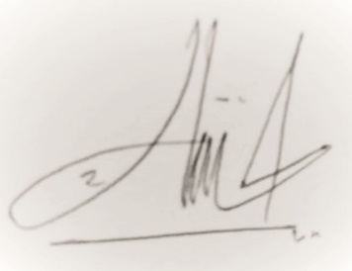

Muhammad Asnajib, S.Ag

Noted: Please upload this letter (in supplementary file) when you submit the article to the Diya al-Afkar: Jurnal Studi al-Qur’an dan al-Hadis

