Meta data Customer Loyalty during COVID-19 Outbreak: The Mediation of Customer Satisfaction in Islamic Bank
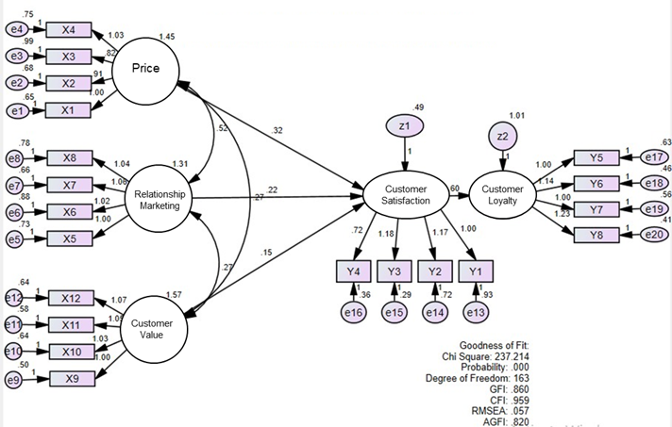 Result of statistic
Respondent Characteristics
The characteristics of respondent in this study consisted of gender, age, education, occupation, length of time as a Islamic bank’s customer, and frequency of transactions.
Respondent profil
Characteristics | Frequency | %
gender
Male | 103 | 42.2
Female | 141 | 57.8
Age
17-20 th | 77 | 31.5
21-30 th | 68 | 27.8
31-40 th | 52 | 21.3
41-50 th | 39 | 15.9
> 50 th | 8 | 3.2
Education
Junior High School | 26 | 10.6
Senior High School | 93 | 38.1
3 Diploma | 45 | 18.4
Bachelor | 69 | 28.2
Magister/Doktoral | 11 | 4.5
Occupation
PNS/Employees | 57 | 23.3
Entrepreneur | 70 | 28.6
Student | 80 | 32.7
TNI/POLRI/ABRI | 7 | 2.8
Others | 30 | 12.2
Length of time as a Islamic bank’s customer
1-2 th | 89 | 36.4
2-3 th | 68 | 27.8
3-4 th | 27 | 11.0
4-5 th | 36 | 14.7
> 5 th | 24 | 9.8
Frequency of transactions
1x a month | 92 | 37.7
2x a month | 67 | 27.4
3x a month | 33 | 13.5
4x a month | 20 | 8.1
> 5x a month | 32 | 13.1
Source: primary data, processed by author.

